# Question 3 – Test Data

## tAccount Statements:

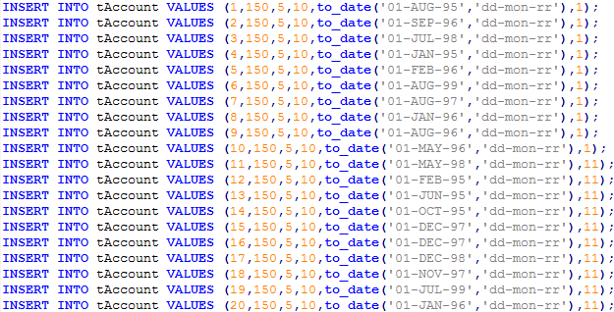

## tBranch Statements:

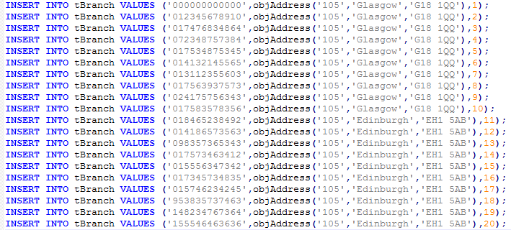

## tCurrentAcc Statements:

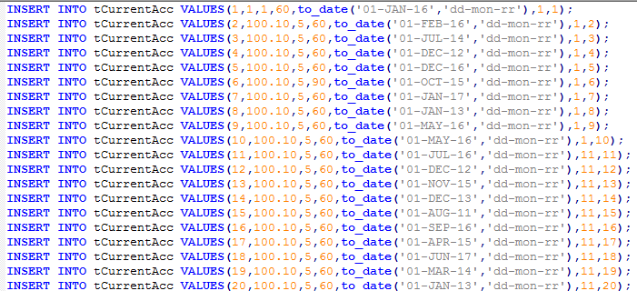

## https://i.gyazo.com/09cea6f43b169039f3ebe9de530d1ec3.pngtCustomer Statements:

## https://i.gyazo.com/328fca969f2389f1cb0b7558a4f79145.pngtEmployee Statements:

## tSavingAcc Statements:

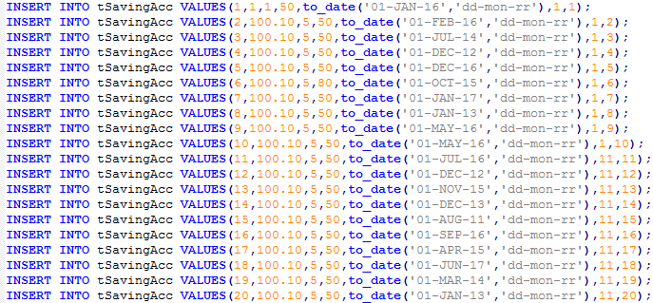

If unable to read any of the statements, they are be included in Q3 – Test Data SQL Scripts folder.

# Test Data Tables

## tAccount Table:

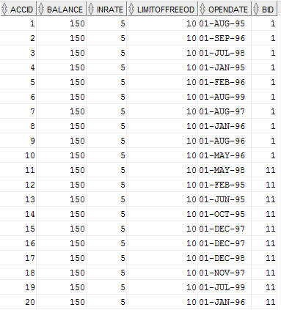

## tBranch Table:

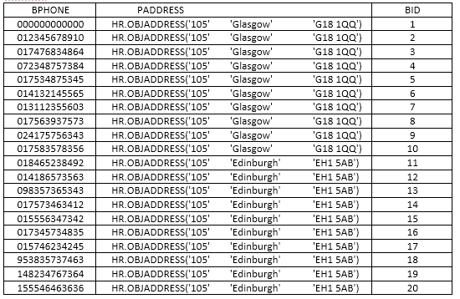

## tCurrentAcc Table:

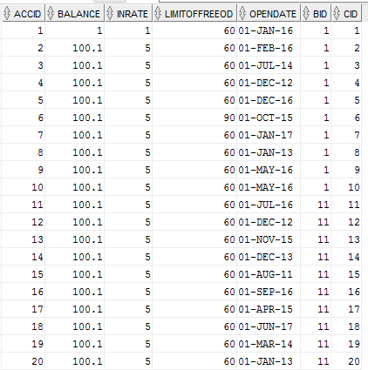

## https://i.gyazo.com/4853df53d9c8c75ac439ddac86b51080.pngtCustomer Table:

## tEmployee Table:

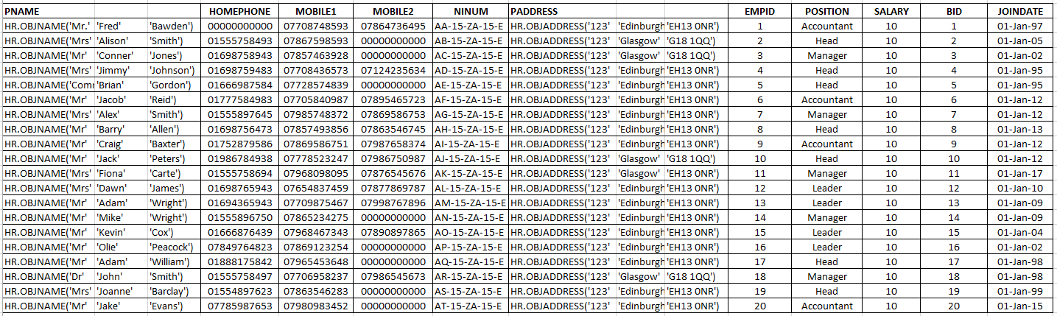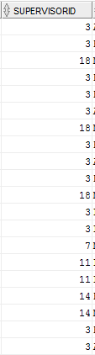

## tSavingAcc Table:

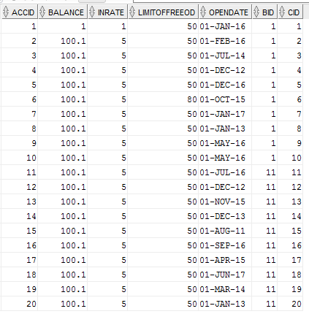

# Question 4 – SQL Queries & Outputs

4a:

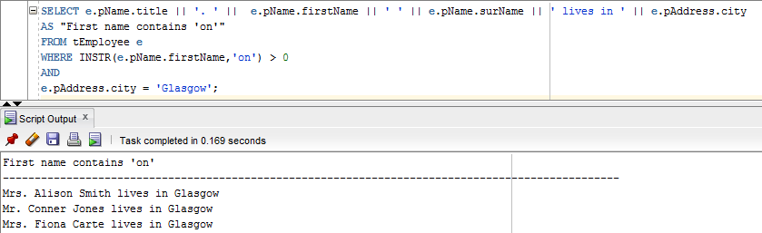

4b:

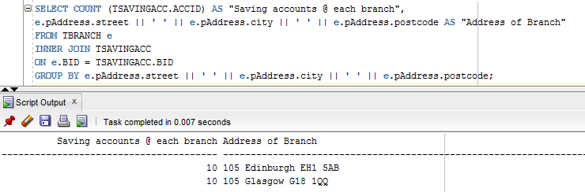

4c:

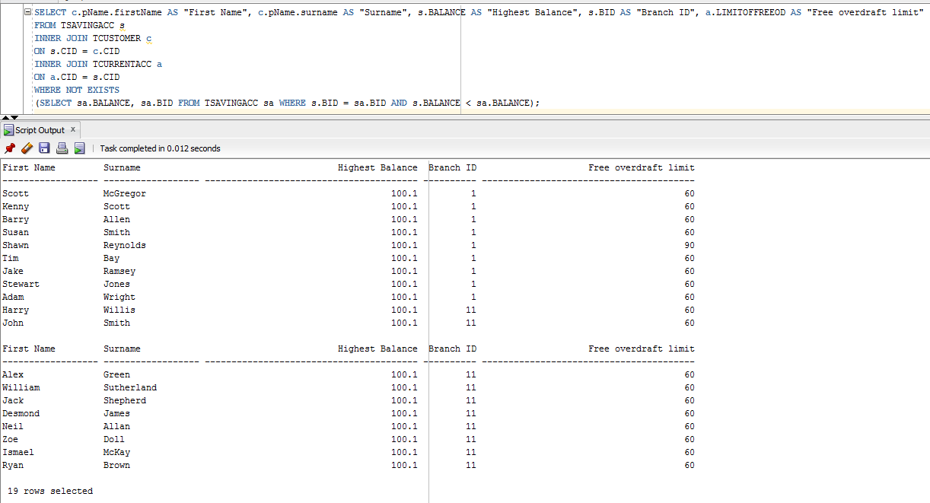

4d:

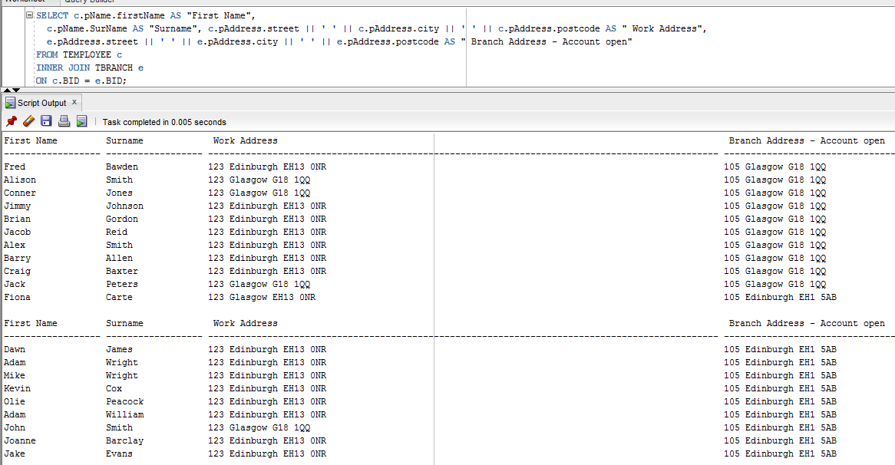

4e:

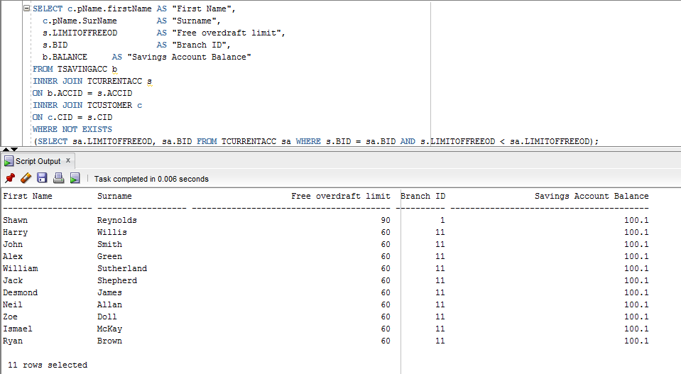

4f:

# https://i.gyazo.com/88e396c2a0e82819a7438f2543831b6c.png

# https://i.gyazo.com/6e810fa1b9154e78f3cf30855fc00d16.pngDatabase SQL – (Code used to create Database)

